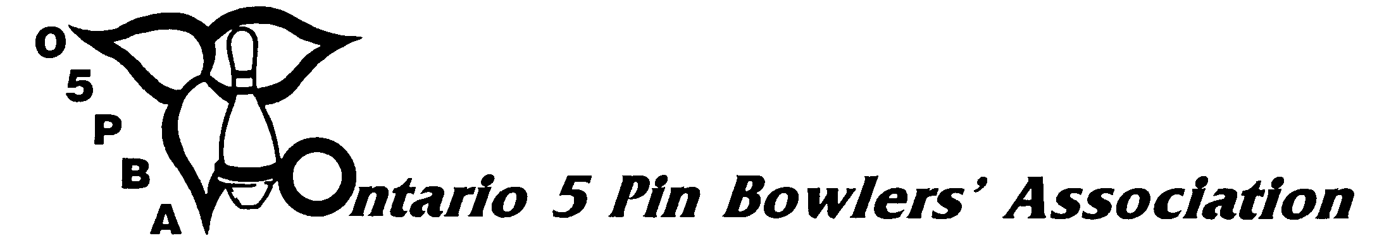

2014/2015 ONTARIO OPEN CHAMPIONSHIPS AND SENIOR OPEN CHAMPIONSHIPS

DECLARATION OF INTENT FORM

BOWLER COACH BOTH

To: , Tournament Director
(Name) (Zone)

I, hereby state my intent to bowl in the Zone
(Print Name)

Open Roll-off for the 2014/2015 bowling season in the above named Zone. I am currently, and was during the 2013/2014 season, a registered member of an O5PBA sanctioned or affiliated league in the

League at .
(League Name) (Bowling Centre Name)

DEFINITION OF LEAGUES:

SANCTIONED – A league will be registered and sanctioned providing that 75% of the participating bowlers purchase a membership card.

AFFILIATED – A league will be affiliated providing that at least ten (10) bowlers from the league purchase a membership card. Included with those bowlers must be the President, Secretary and Treasurer of the league.

PLEASE NOTE: All bowlers/coaches must purchase a membership card in the Zone they are declaring to bowl/coach in. It is the responsibility of the bowler/coach to make sure that all criteria for declaring are submitted to the O5PBA office. All rules and regulations governing the Open declarations can be found on our website at www.o5pba.ca.

I am attaching a copy of my current year (2014-15) average sheet confirming my participation in said league or in another league within that same Association. In the prior season I bowled a minimum of fifty (50) games in a sanctioned or affiliated league of the Zone I am declaring in, and I am listed on the o5pba.ca website average book for said league to verify my eligibility to declare.

OVER ➔
The League Secretary has signed below to indicate that my current average sheet is a true copy. I understand that the cost of a zone shirt may be at my own expense.

(Signature)

I verify that the information for the above named person is true.

(League Secretary’s Name) (League Secretary’s Signature) (Date)

NEW THIS YEAR: The following motion was passed by the delegates at the O5PBA Annual Convention in June 2014:

REMOVE THE 50-GAME CRITERIA FOR A COACH WHO IS NOT ACTIVELY BOWLING AT ALL (NOT AN O5 MEMBER FROM ANY LEAGUE) SO THEY CAN COACH IN A NON-RESIDENT ZONE.

I declare that I am a certified coach who is not actively bowling at all and am not an O5 member in any league. I acknowledge that I am required to purchase a membership card in the Zone in which I am declaring to coach in.

(Signature)

I verify that the information for the above named person is true.

(Zone/DC President’s Name) (Zone/DC President’s Signature) (Date)

NAME: MEMBERSHIP #:

ADDRESS: CITY:

POSTAL CODE: TELEPHONE #: ( )

E-MAIL ADDRESS:

RECEIVED BY: DATE:

